THE ART WORLD OF WILLIAM MARR

Paperback & eBook – February 14, 2022

Bilingual (Traditional Chinese/English) Edition
by Tang Lingling Zhou Weimin (Author), Shixin Li (Editor)

https://www.amazon.com/-/he/Tang-Lingling-Zhou-Weimin/dp/B09SV7GN2P?tag=namespacebran383-20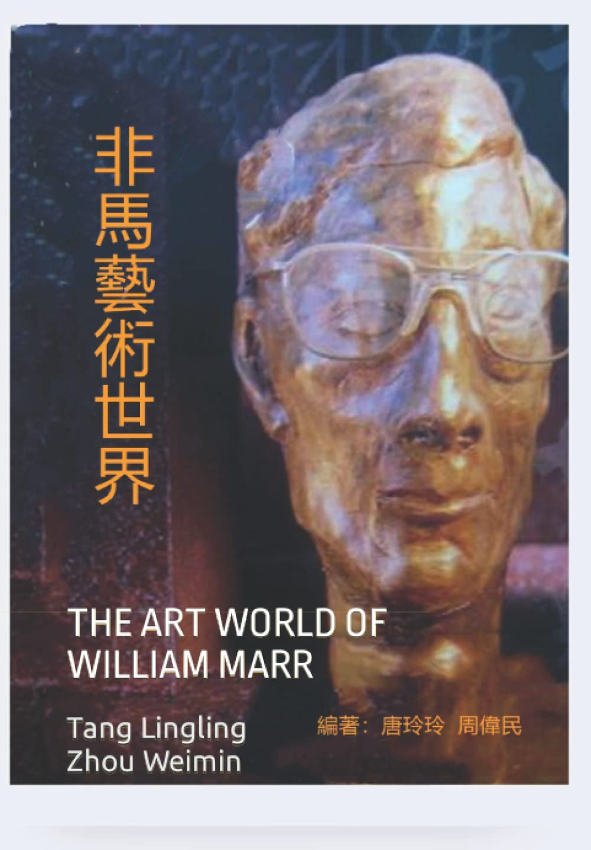 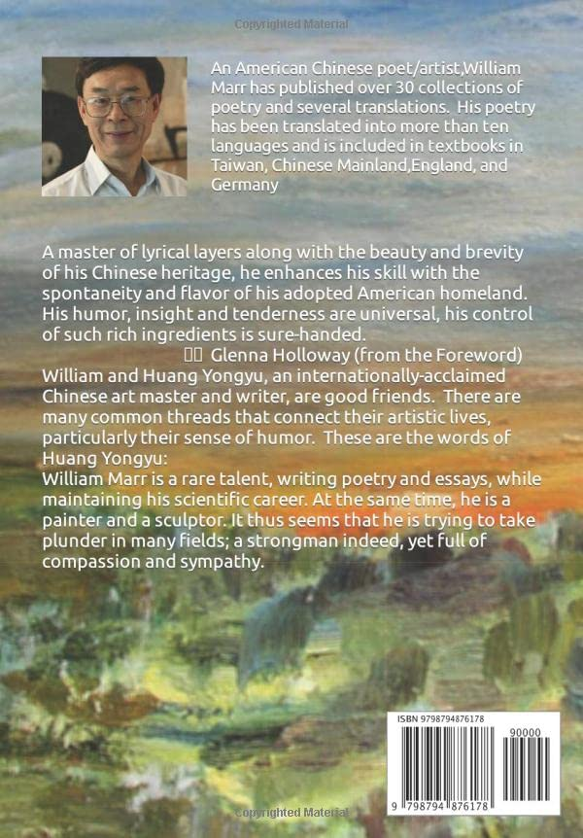

FOREWORD
Li Shi Xin

William and Huang Yongyu, an internationally-acclaimed Chinese art master and writer, are good friends. There are many common threads that connect their artistic lives, particularly their sense of humor. These are the words of Huang Yongyu:
William Marr is a rare talent, writing poetry and essays, while maintaining his scientific career. At the same time, he is a painter and a sculptor. It thus seems that he is trying to take plunder in many fields; a strongman indeed, yet full of compassion and sympathy.
Writer/critic Zong Ying once wrote:
In Chinese, Marr literally means horse. William Marr is indeed a gallant horse, galloping freely in the field of world poetry. As Dufu said in his poem, A Song of Painting to General Cao: "The emperor told you to spread out a piece of silk / with laborious design you worked and worked. / Soon a dragon-horse emerges from the sky, / banishing earthly horses for thousands of years." We probably can also say that William Marr banishes earthly horses from the realm of poetry.
POSTSCRIPT
William Marr（非馬）
I believe every person has his or her own set of sporadic life memories. What is difficult is to take that set of memories and create an overall picture. Before and after the publication of the simplified Chinese version of this book in 2010, there have existed several books about my poetry, including The Poetic Art of William Marr (Yang Zongze, Writers Publishing House, Beijing, 1999), William Marr's Poetry Creation (Liu Qiang, China Federation of Literary and Art Circles Publishing Corporation, Beijing, 2001), William Marr's Poetry World (Liu Qiang, New Century Aesthetics Press, Taiwan, 2017), and Appreciation of Bilingual Poems by William Marr (Professor Zhang Zhizhong,Tianjin University Press, 2018). All of these books presented a deep study of my poetic world. Yet, none of them captured the growth processes of my life journey, namely my family, my career in the field of engineering, my life as an artist, and the fusion of my poetry and art by combining my paintings with my poems, as in the case of this book. In recent years, friends and colleagues have suggested that I write an autobiography. In response, I told them that this book represents a more complete and objective summary of my life than any narrative that I could write about myself.
My sincere thanks to Mr. Li Shixin of Washington Writers Press, who wrote a wonderful review of some of my poetry about twenty years ago, for his suggestion of publishing the present version of the book with traditional Chinese characters in paperback, hardcover as well as eBook formats. Hopefully, that will provide a convenient opportunity for interested readers throughout the world to share in this latest project.

